DIT ONLINE CANDIDATES REGISTRATION USER MANUAL
FOR DIT ASSESSMENT CENTRE
October 29, 2020
Directorate Of Industrial Training Ministry Of Education And Sports
Plot 97/99 Jinja Road/Corner, 3rd Street. P.O. Box 20050Lugogo, Kampala, Uganda.+256 414 259412, +256 414 251256 (ADMIN)+256 414 253704 (Qualifications Standards)+256 414 232124 (Assessment & Certification)

Contents
HOW TO USE DIT ONLINE REGISTRATION 2
Requesting for user account 2
Logging into the system 2
Functions of the system 3
Occupation Assessed by DIT 4
Registration menu 4
The registration menu 4
Register candidate 5
Creating assessment schedule 6
Select Modules 7
Adding new candidates/ late registration 7
Submit candidate 9
Creating candidate’s album 9
Attach documents and submit candidates 12
Submitted Registration 13
Approved Registration 14

HOW TO USE DIT ONLINE REGISTRATION
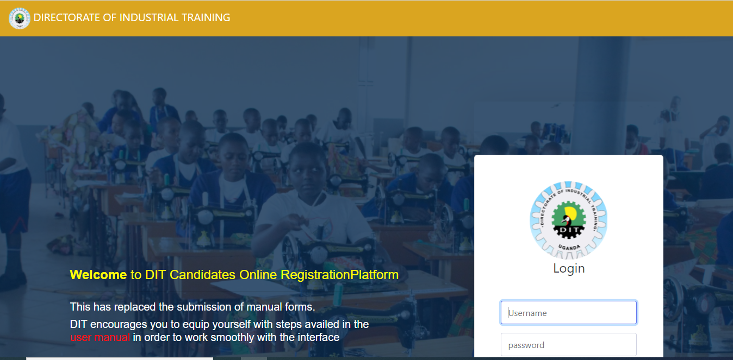

Requesting for user account
Fill in the form below to request the system admin to create for your user account. The account details will be sent to you via your email address you registered with.
Steps
- Click on request account for assessment centre
- Fill your details required
- Click on register button
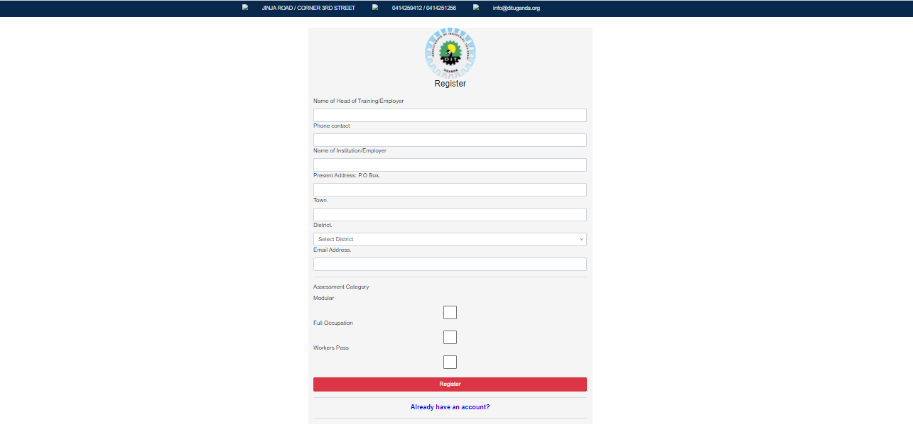

Logging into the system
After typing in the user details sent to your e-mail from the DIT system admin, it will grant access to use the system.
As shown below i.e. before logging in
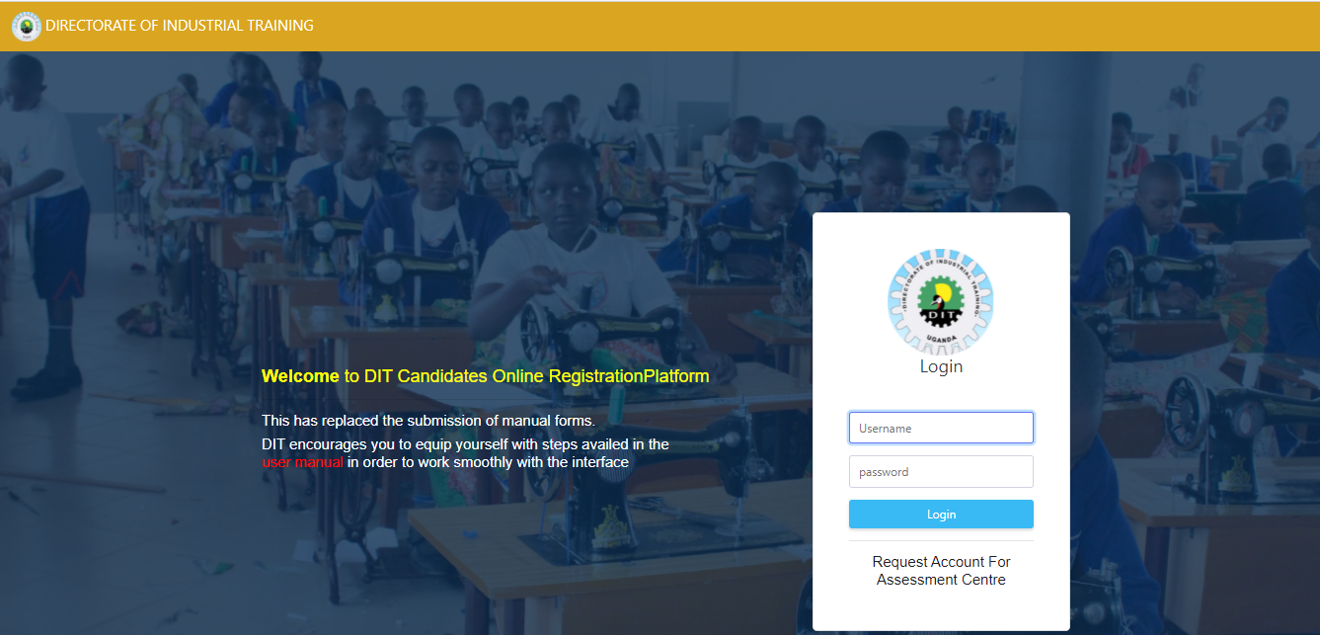
After logging in
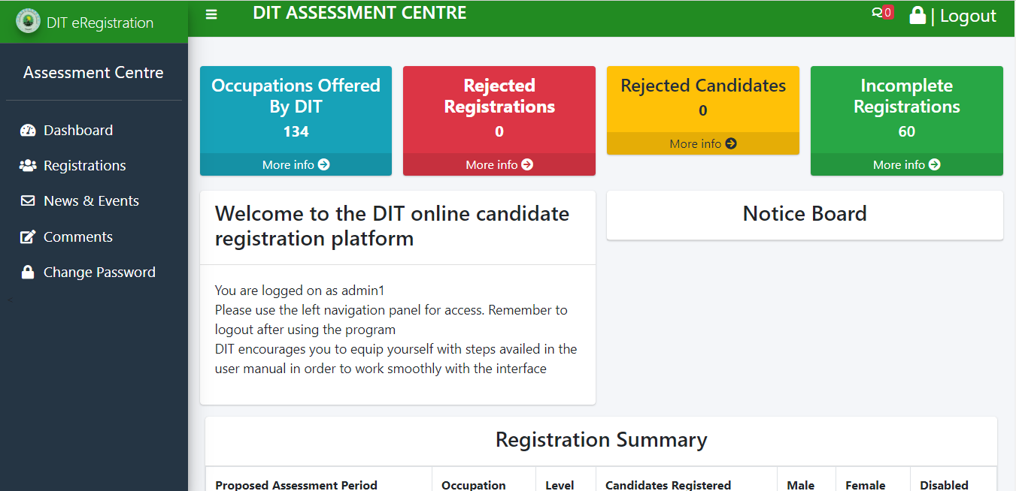

Functions of the system
The system will give access to the following functions;
- Occupation assessed by DIT
- Registration
- Rejected registrations
- Rejected candidates
- Incomplete registration

Occupation Assessed by DIT
To view occupations offered follow the following steps
- Click on dashboard
- Click on more info under occupations assessed function
The window showing some of occupations assessed by DIT will display as below;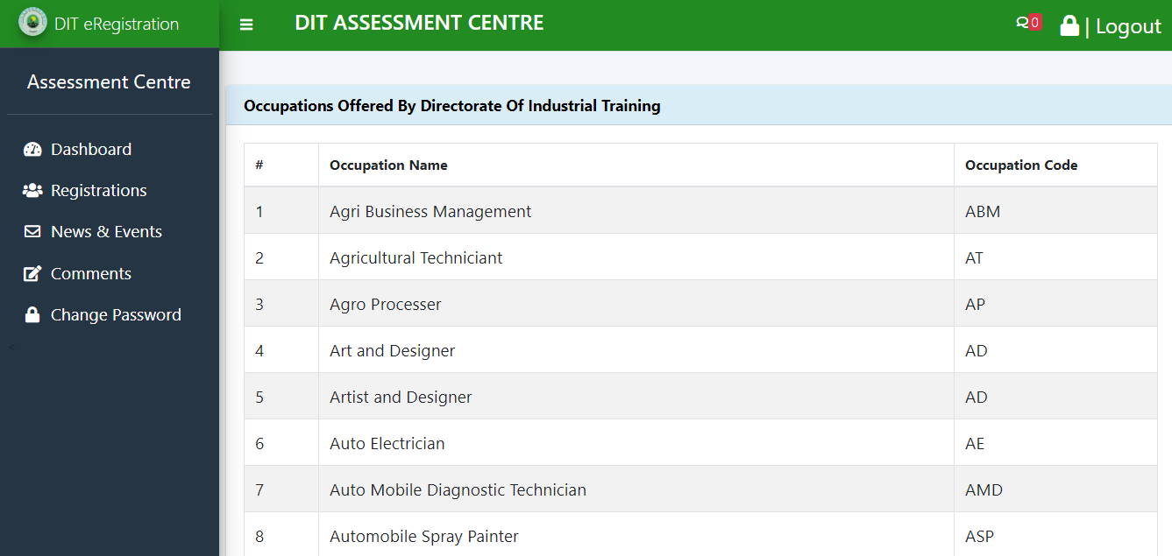

Registration menu
This function allows a centre to register candidates to different occupations and level of assessment as confirmed during the accreditation of that particular assessment centre.

How to register a candidate?
The following are functions of registration menu
- Register candidate
- Incomplete registration
- Submit registration
- Submitted registrations
- Approved registrations

The registration menu
Steps of displaying the registration menu
- Click on registration
The registration menu is shown below
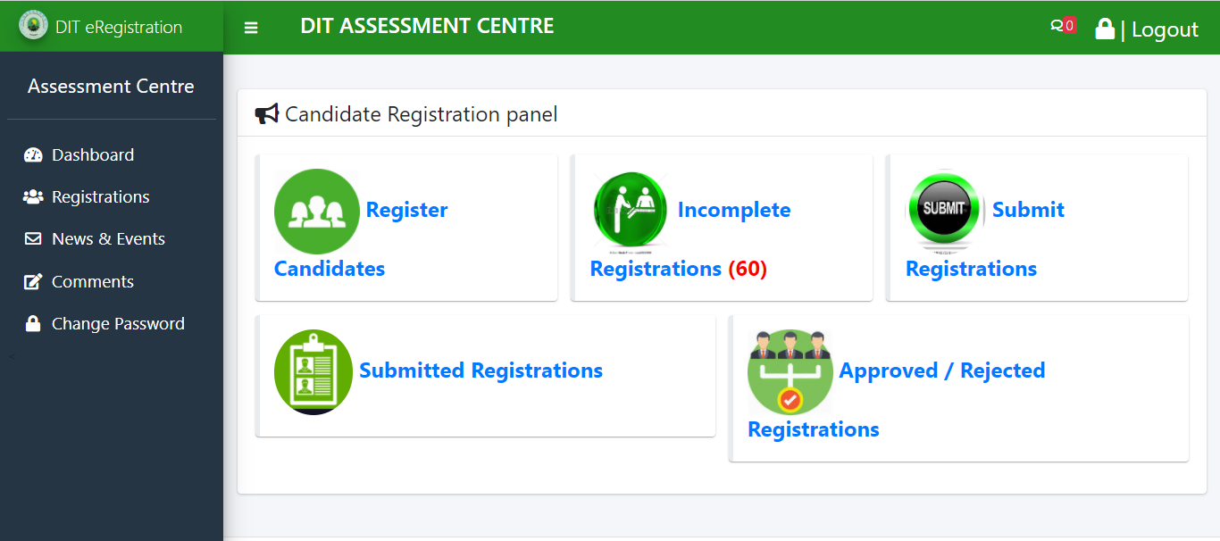

Register candidate
This function allows centres to register candidate for assessment
Steps followed
- Click on registrations
- Select Register candidate
- Select occupation
- Select assessment type
- Click continue
As shown below

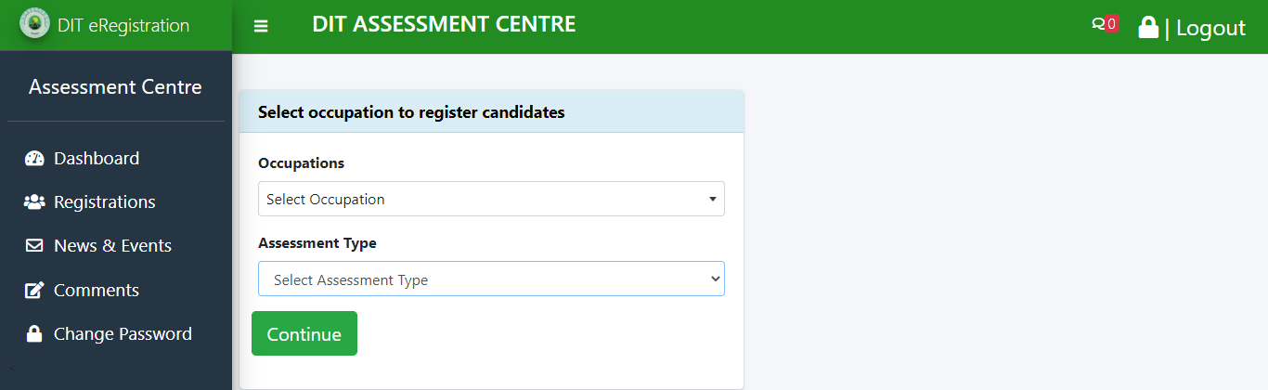

Creating assessment schedule
This is the assessment period which consists of start date, end date and proposed date of assessment.
Steps
- Click continue from register candidate window to link you to Add Training Details
- Select the Training Start Date
- Select the Training End Date
- Select the Proposed Assessment Date
- Select the Assessment Centre Location
- Click continue to create assessment schedule and Select Modules.
As shown below

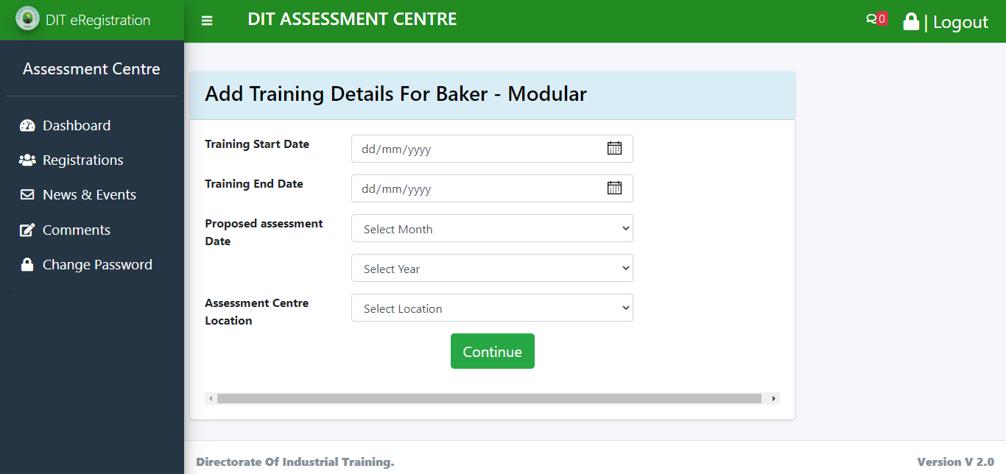

Select Modules
This function enables you to select the correct modules assessed for that particular module.
Steps
- Click continue from Add Training Details to link you to select module window
- Tick module
- Click save and continue
As shown below
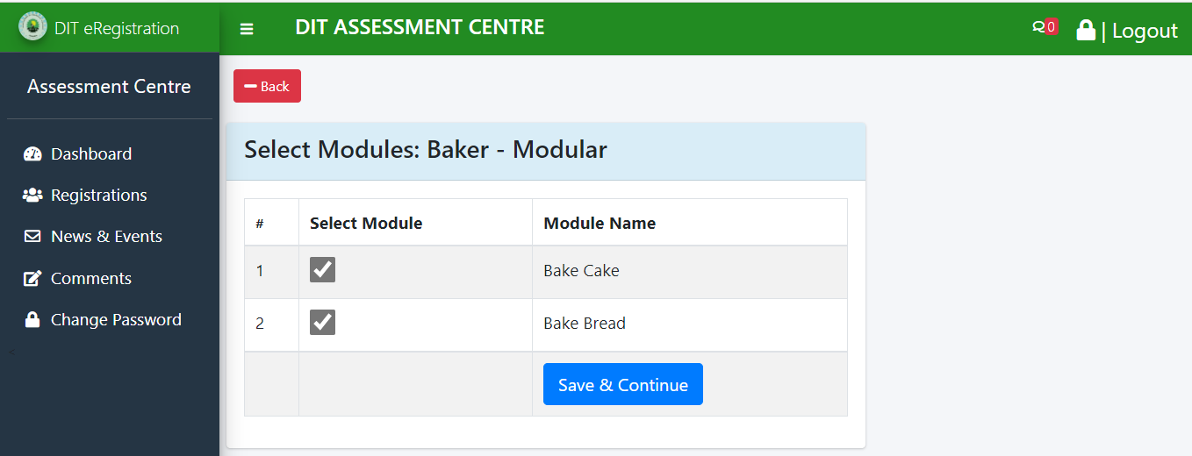
Note:
- At this stage the assessment period and modules assessed is scheduled and created

Adding new candidates/ late registration
This allows you to add candidates to the already existing candidate list even after submission for registration to DIT. This is where candidate’s details are captured from.
Steps
- Select the start- end date you have scheduled
- Click view and add link
- Click on Add a new candidate button to add candidate’s details
- It will show Application Form for Assessment
- Click save to add a candidate
As shown below (Add a new candidate)
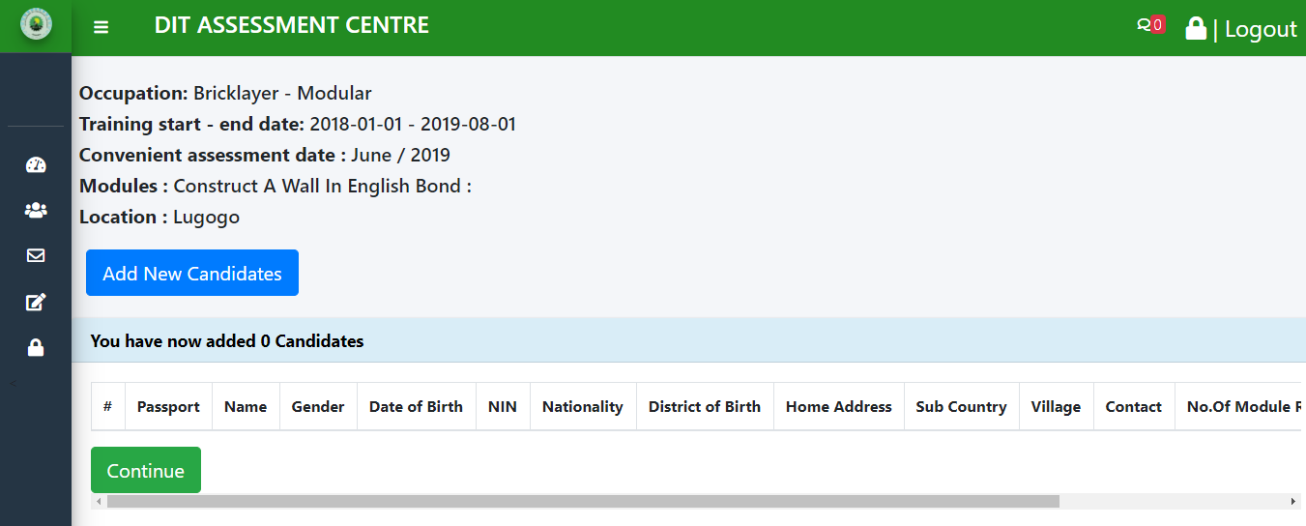

Application Form for Assessment
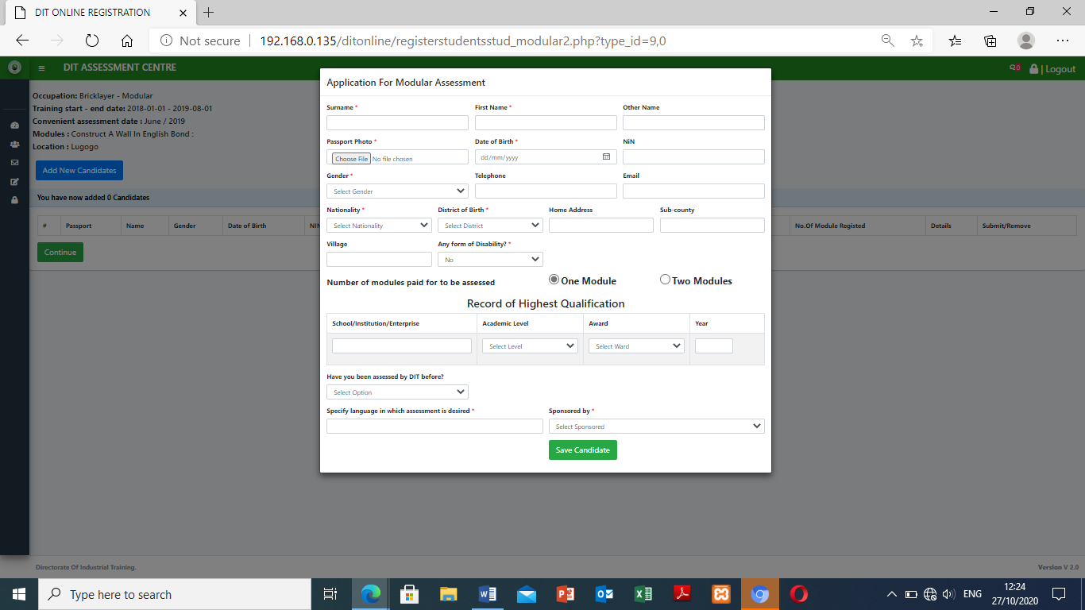
Note
- Fill in all fields with * symbol because they are important and the system can’t save without them filled.
- The total number of candidates registered should be five (5) and above.
- Then click continue button.

Submit candidate
This menu will submit candidates to DIT for approval and to be given registration numbers. This is done after registered candidates have finished approving their bio data details, signed against them and paid for registration. Scan approved candidate bio data and paid receipt in pdf format then upload as an attachment to the system. The power over these registered candidates on the assessment centre stops at this stage
Steps
- Click on registration
- Select submit candidate
- Select proposed assessment period
- Select the assessment centre location
As shown below

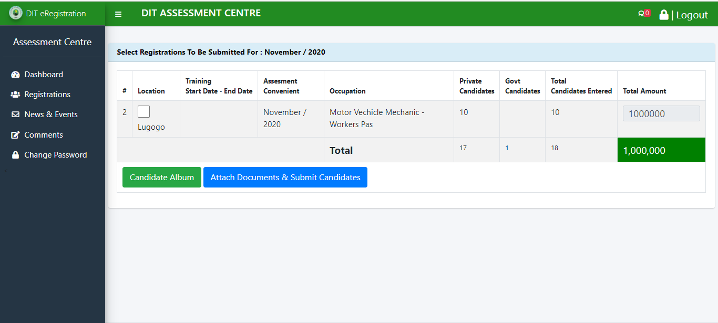

Creating candidate’s album
This shows the candidates photo and bio data where candidates sign against their names to approve. It is scanned after candidate’s approval then sent as an attachment to DIT
Steps
- Click on registration
- Click submit registration
- Select proposed assessment period
- Click on view & attachment
- Tick the location from the Selected Registrations to be Submitted
- Select candidate album
- Select from Submission Batch
- Select Centre Location
- Select Occupation
- Select Assessment Type
- Click Apply
- Then click on print candidate album

The table below shows the sequence of steps and pictures of windows appearance at different steps as shown below;
- Click on registration  - Click submit registration | 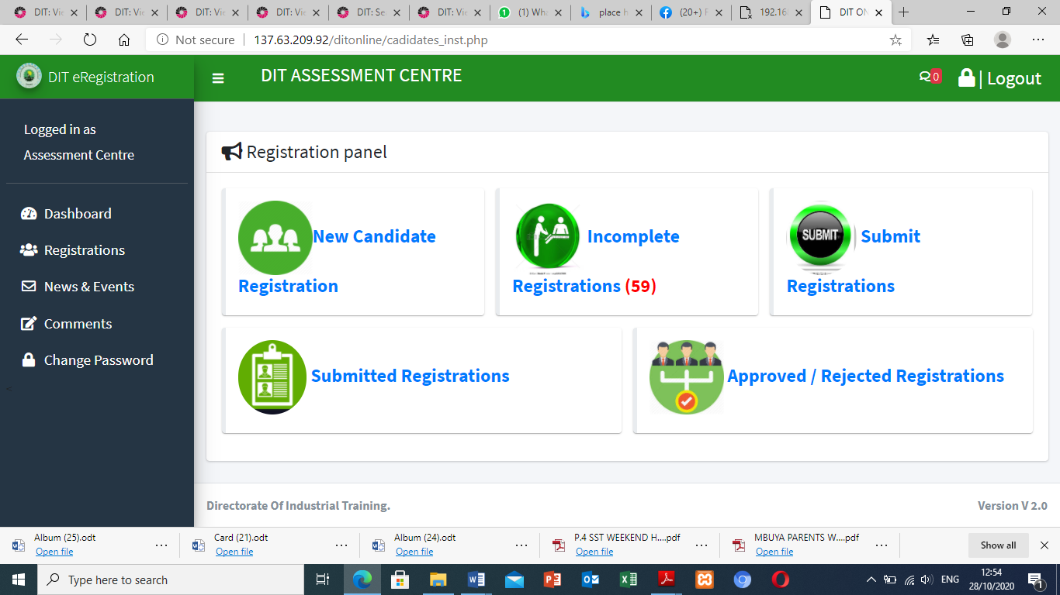
- Select proposed assessment period  - Click on view & attachment | 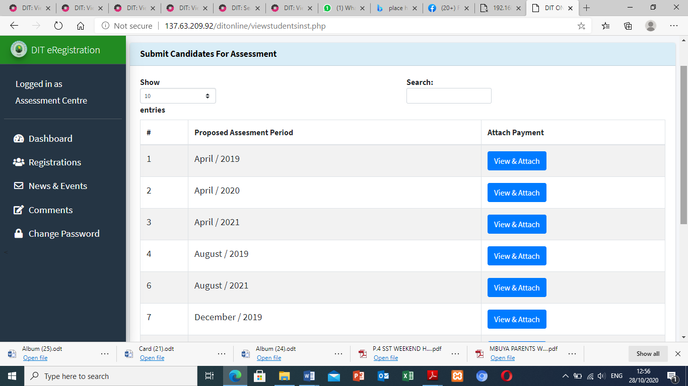
- Tick the location from the Selected Registrations to Be Submitted  - Select candidate album | 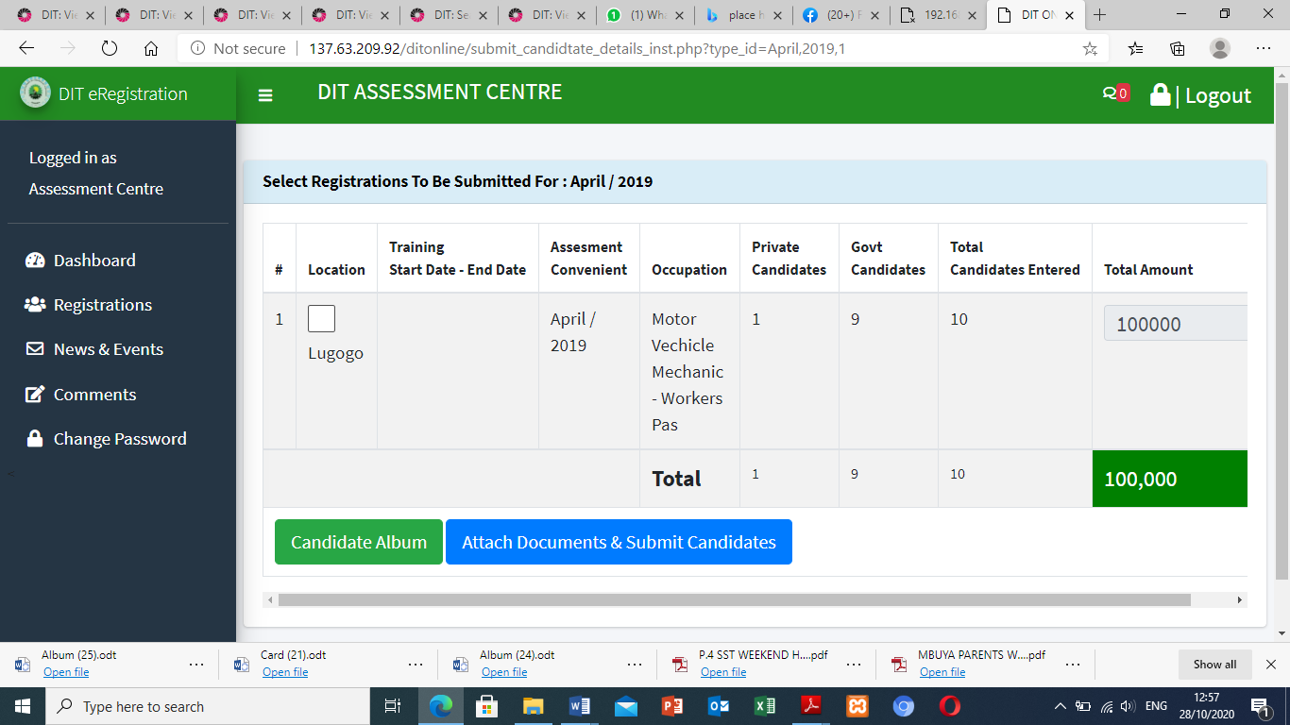
- Select from Submission Batch  - Select Centre Location  - Select Occupation  - Select Assessment Type  - Click Apply | 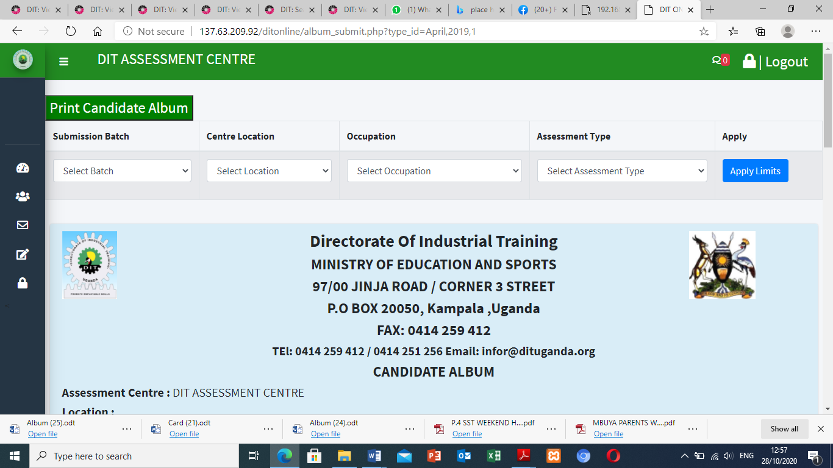
- Candidates album | 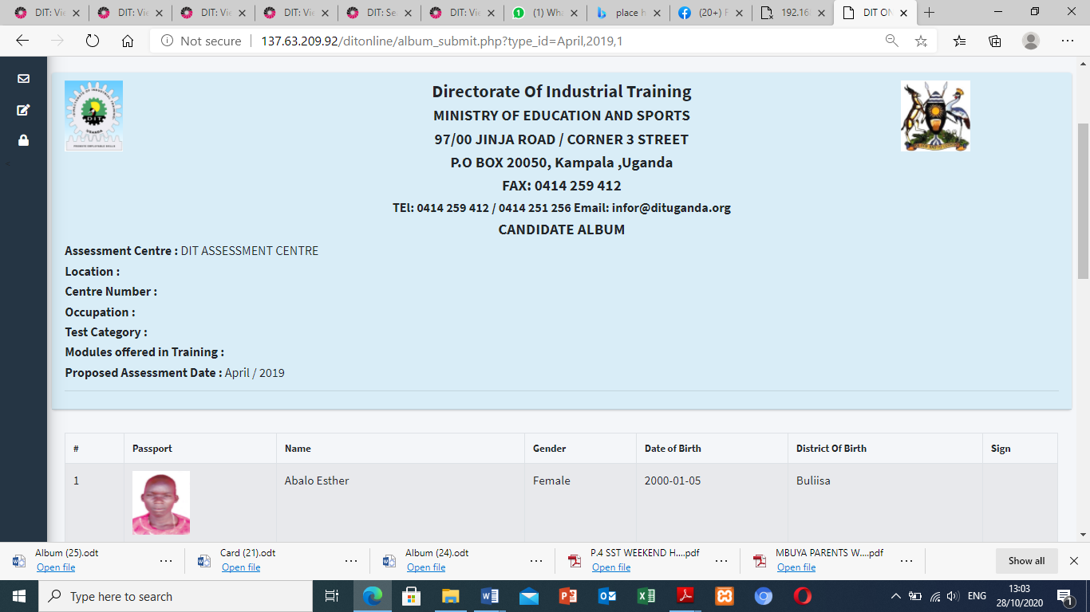
- Command to Print | 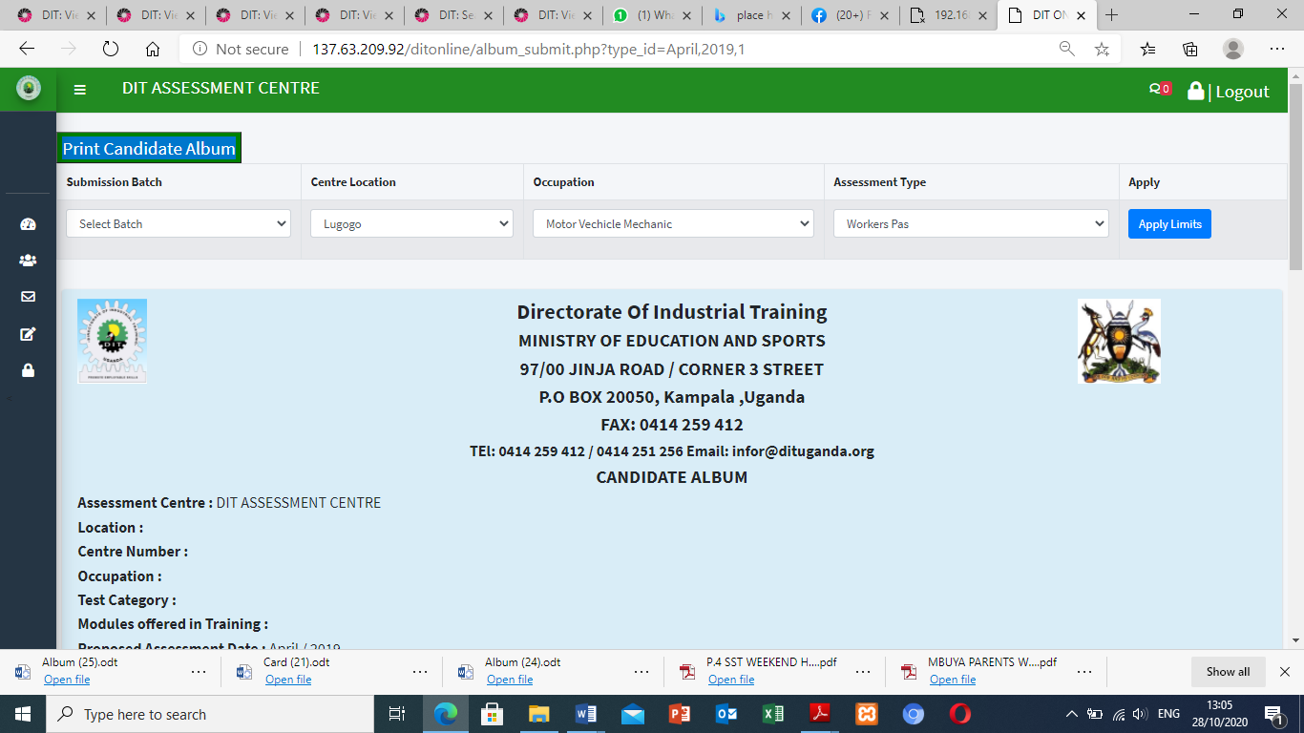
Printing  - Select a printer  - Select copies  - Select layout  - Select pages  - Click save/ print | 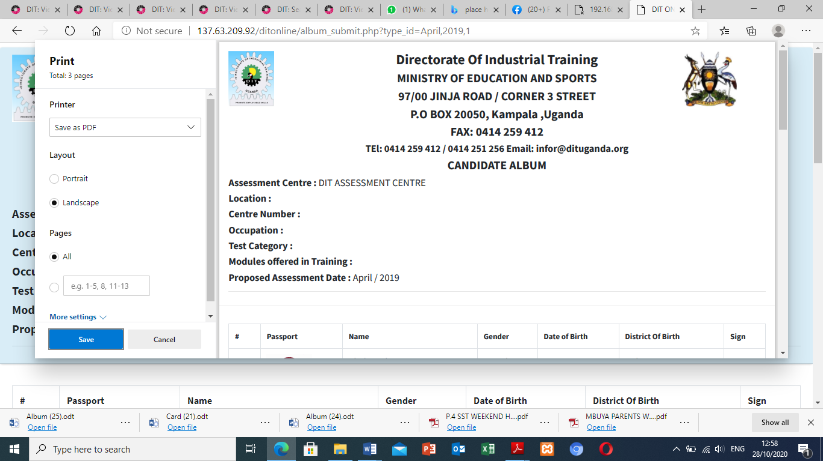

Attach documents and submit candidates
This function allows a centre to capture the payment details and upload a scanned paid bank slip/ receipt.
Steps
- Click on registration
- Click registration
- Select proposed assessment period
- Click on view & attachment
- Tick the location from the Selected Registrations to Be Submitted
- Select Attach documents and submit candidates
- Capture the following
- submission Date *
- Mode Of payment i.e. bank slip, EFT receipt EFT cheque others
- Payment Document No. *
- Attach Payment Document *
- Candidate Album *
- Contact Person *
- Contact 1 *
- Contact 2
- Then click submit candidate
Note: fields with* symbol are very important
As shown below

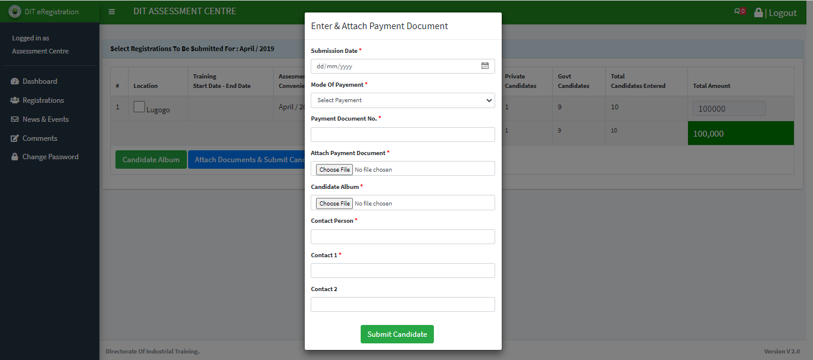

Submitted Registration
This function displays the candidates submitted for registration. The centre just views what it submitted and cannot do any editing on this data.
Steps
- Click on registration
- Select ed registration
As shown below
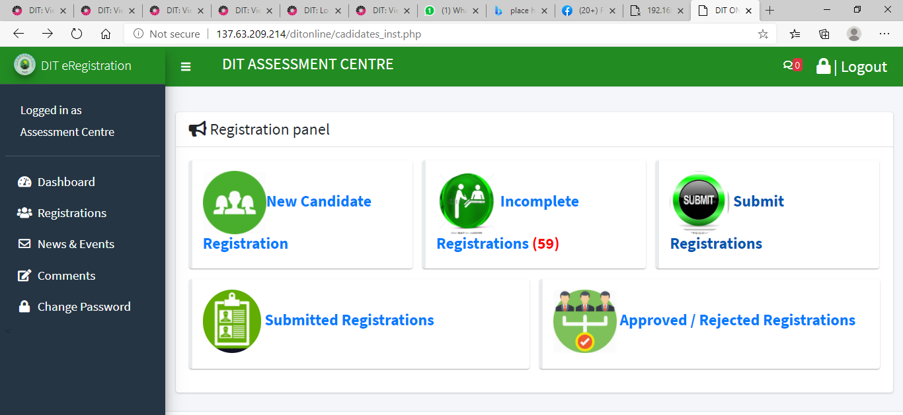
2
1

Approved Registration
This displays list of candidates and their assessment schedules that are approved by DIT.
Steps
- Select registration
- Select Approved Registration/ rejected registration
- Select either approved, Rejected Registrations and Rejected Candidates
As shown below
